Chapter 19, Solution 36.

We replace the two-port by its equivalent circuit as shown below.

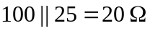
2 I₁
+
−
+
−
100 
16 
10 V
3 V₂
4 
I₁
I₂
+
V₁
−
+
V₂
−
25 
-2 I₁

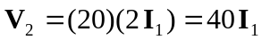 (1)



 